1. Knowing circuit from the figure 1, determine the currents and verify the results with power balance.

$${\text{R}}_{\text{1}}\text{=}\text{200 Ω; }{\text{R}}_{\text{2}}\text{=100 Ω; }{\text{L}}_{\text{1}}\text{=3 H; }{\text{L}}_{\text{2}}\text{=2 H; }{\text{L}}_{\text{12}}\text{=1 H;}{\text{C}}_{\text{2}}\text{=}\frac{\text{1}}{\text{20}}\text{ mF; }$$

$${\text{u}}_{\text{e}}\text{=600}\sqrt{\text{2}}\text{sin}\left(\text{100t}\right)\text{[V].}$$

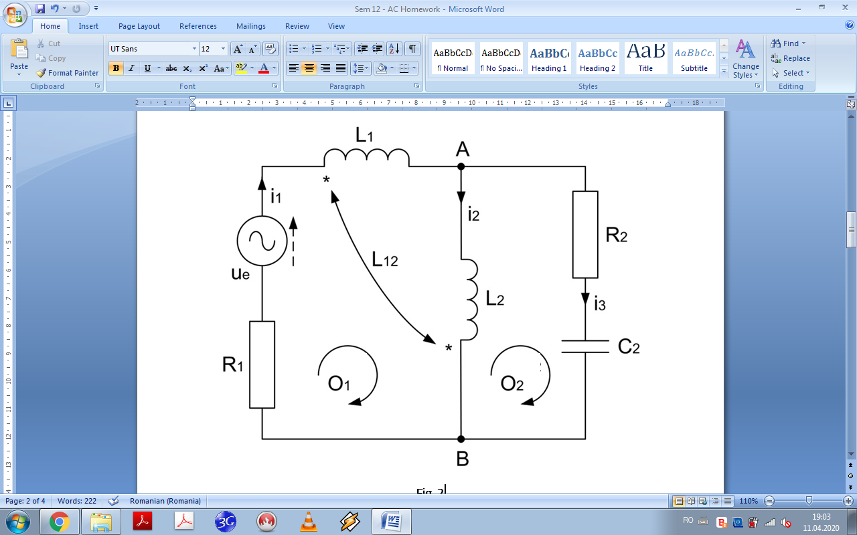

**Fig. 1**

**Results**

$${\text{i}}_{\text{1}}\text{=}\text{2 sin}{\text{(100}\text{t-}\frac{\text{π}}{\text{4}}\text{) [A]; }{\text{i}}_{\text{2}}\text{=2}\sqrt{\text{2}}\text{ sin}\left(\text{100t}\text{-}\frac{\text{π}}{\text{2}}\right)\text{ [A]; }}$$

$${\text{i}}_{\text{3}}\text{=}\text{2 sin}\left(\text{100}\text{t+}\frac{\text{π}}{\text{4}}\right)\text{ [A]; }$$

$${\text{P}}_{\text{G}}\text{=}{\text{P}}_{\text{Z}}\text{=600 W;}$$

$${\text{Q}}_{\text{G}}\text{=}{\text{Q}}_{\text{Z}}\text{=600 VAr.}$$

1. Knowing the elements in the figure 2, determine the currents and verify the results with power balance.

$$\text{R=1 Ω; }{\text{L}}_{\text{1}}\text{=}\frac{\text{1}}{\text{100π}}\text{ H; }{\text{L}}_{\text{2}}\text{=}{\text{L}}_{\text{12}}\text{=2}{\text{L}}_{\text{1}}\text{; C=}\frac{\text{1}}{\text{100π}}\text{F; f=50 Hz;}$$

$${\text{u}}_{\text{e1}}\text{=2}\text{sin}\left(\text{ω}\text{t+}\frac{\text{π}}{\text{4}}\right)\text{[V];}{ \text{u}}_{\text{e2}}\text{=}\sqrt{\text{2}}\text{sin}\left(\text{ω}\text{t-}\frac{\text{π}}{\text{2}}\right)\text{[V];} {\text{u}}_{\text{e3}}\text{=}\sqrt{\text{2}}\text{sin}\left(\text{ω}\text{t+}\frac{\text{π}}{\text{2}}\right)\text{[V].}$$

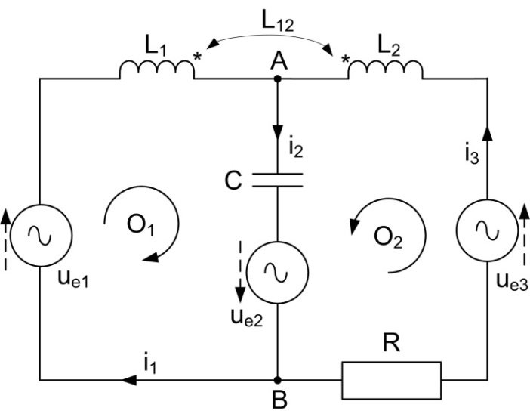

**Fig. 2**

**Results**

$${\text{i}}_{\text{1}}\text{=2}\text{sin}\left(\text{ω}\text{t+}\frac{\text{π}}{\text{4}}\right)$$

$${\text{i}}_{\text{2}}\text{=}\sqrt{\text{2}}\text{sin}{\text{ω}\text{t}}$$

$${\text{i}}_{\text{3}}\text{=}\sqrt{\text{2}}\text{sin}{\text{ω}\text{t}}\text{-}\frac{\text{π}}{\text{2}}\text{)}$$

$${\text{P}}_{\text{G}}\text{=1 W; }{\text{Q}}_{\text{G}}\text{=-1 VA}\text{r}$$